**Teleporting duck**

## Step 1: Make it

### What is it?

Make a duck fly invisibly through the air from one micro:bit to another.

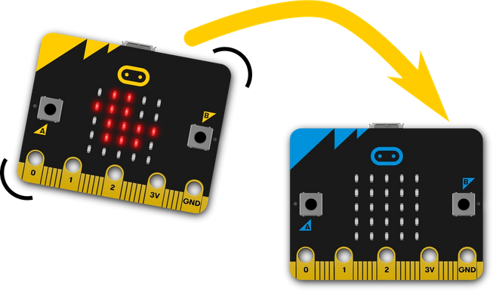

### How it works

* Flash this program onto two micro:bits, shake one and a duck appears to travel magically through the air from one to the other. Shake the other to send it back.
* It’s not really magic. It uses the micro:bit’s [radio](https://microbit.org/get-started/user-guide/features-in-depth/#radio) function to send data from one micro:bit to another when the [accelerometer](https://microbit.org/get-started/user-guide/features-in-depth/#accelerometer) detects a shake gesture.
* The program first sets the radio group to 23. Groups are like channels on walkie-talkie radios; they can be number between 0 and 255. It doesn’t matter what number you pick as long as your friend’s micro:bit is using the same group number, and no-one else nearby is using the same group.
* When you shake it, it sends the word ‘DUCK’ on that radio group and clears the screen. If either micro:bit receives a radio message (**any** radio message), a duck icon appears on its display, so you should only ever have 1 duck visible at any time.

### What you need

* 2 micro:bits (or MakeCode simulator)
* MakeCode or Python editor
* battery packs (optional)
* a friend to play with

## Step 2: Code it

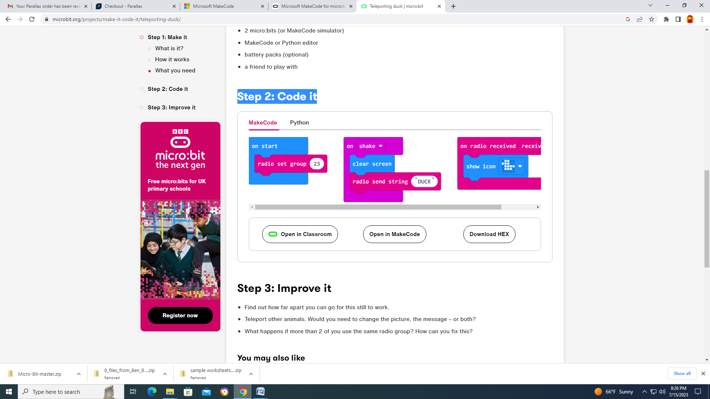

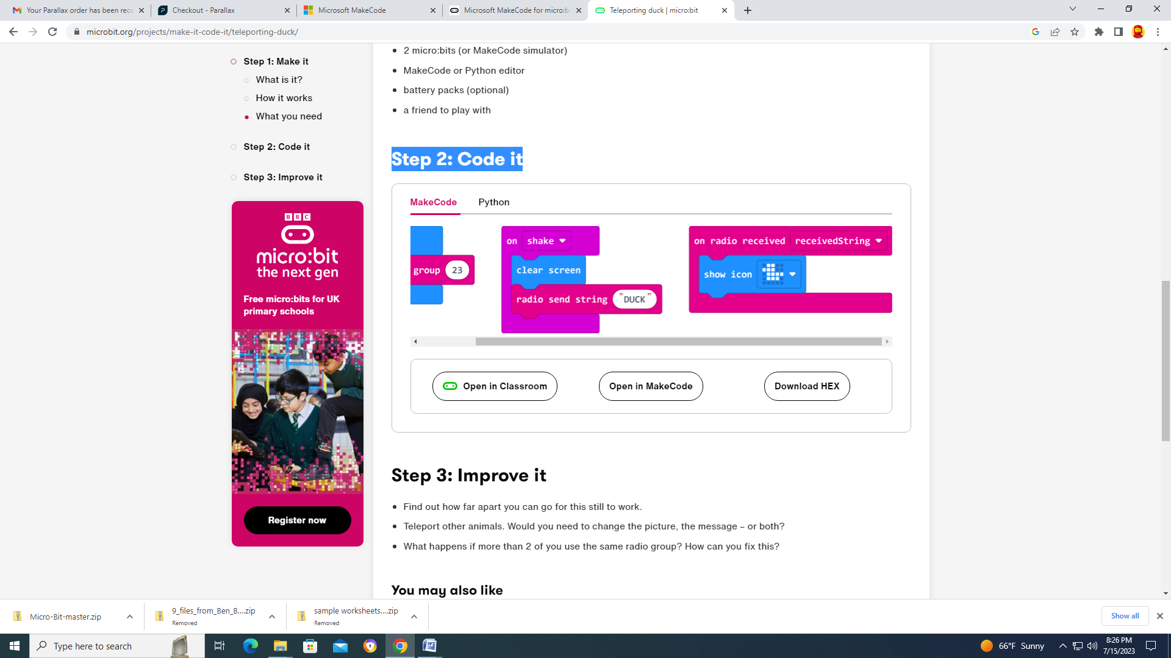

## Step 3: Improve it

* Find out how far apart you can go for this still to work.
* Teleport other animals. Would you need to change the picture, the message – or both?
* What happens if more than 2 of you use the same radio group? How can you fix this?